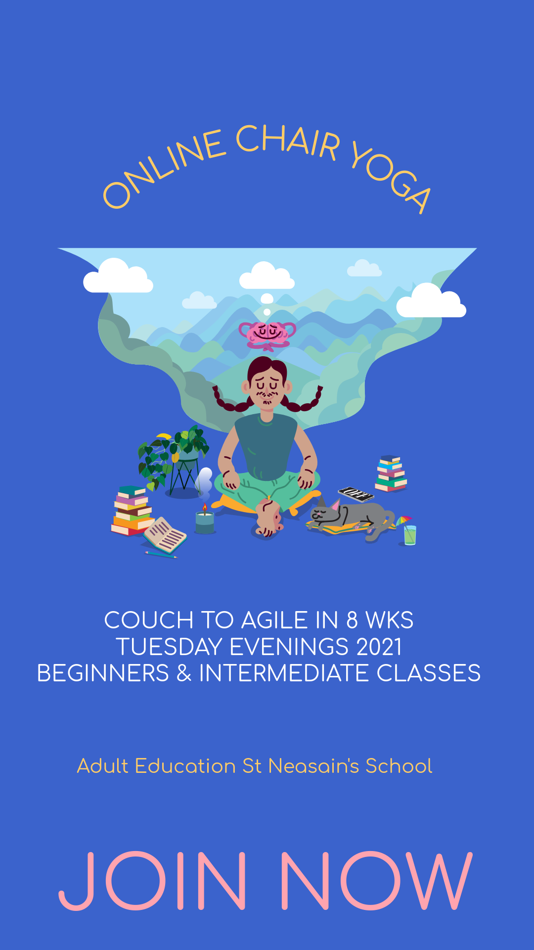

Stretch, Breath & Relax

A one-hour class, once a week in the comfort of your own chair and home.

This class is especially beneficial for people who sit a lot but not entirely, it is for everyone who feels they need to breathe better, stretch better and be a better version of themselves.

Imagine, consciously moving with your breath, expanding your capacity to breathe deeper, for longer, and effortlessly…

Week by week you will get stronger, more agile, more flexible, and more mindful….

Get ready to notice the difference…

This is the class for you. See you on the Chair!

Yoga on & off the Chair

A one-hour class, once a week in the comfort of your own chair and home.

This class is geared up for working the larger muscles groups, toning abs, hips openers, upper and lower body stretching, breath work, awareness and more…

Get chair ready….

This is the class for you. See you on the Chair!

